DATE: | 10/12/2015 | MARINE SAFETY BULLETIN: | 09/15US
 |  | PRIORITY LEVEL: | HIGH
EQUIPMENT: SB-08-2015-Shock absorbers - Mechanic type
Installed only on Davit stations with winch operated by electric lifting motor.
INSTRUCTIONS VALIDITY AND APPLICABILITY:
• Applicability: immediate. The instruction of this Marine Safety Bulletin supersedes any other previous instruction in: OMM, Service Instructions, Service Manuals, and any other instruction in written or verbal mode related to the interval of inspection of any and every mechanic type shock absorber built by Tecnimpianti S.p.A.
• Starting date: Date of issue of the present bulletin.
• End date: this instruction never expires.
• Vessel: all vessels with Tecnimpianti LSA stations with mechanic type shock absorbers.
BULLETIN CONTENT AND CLARIFICATIONS:
The clarification and instruction of this Bulletin applies to all inspections on every Lifeboat / Tender / Rescue LSA Station built by Tecnimpianti S.p.A. that have mechanic type shock absorbers. The mechanic type shock absorbers system has been designed to operate on application heavy duty, as on Tender boats, with maintenance on long time interval.  The above performances have been checked and no one unit has failed in over 15 years of operating life.  The function of the shock absorber is to prevent excessive pulling force on the wire rope and stresses to the davit structures and winch when the block and arms arrives to the mechanical stop in stowed position. At the end of the stroke, the wire rope (8) pulls out the rod of the shock absorber (1); in the shock absorber the rod is kept in position by a set of spring bellows pre-charged at a certain value. When the rod is pulled out the mechanical actuator abandons the limit switch (6) that stops the winch electric motor.  Depending on the boat weight the mechanic shock absorber may have different size therefore different operating force; refer always to the Approved OMM for the operating force of the actual unit.  The present yearly interval of inspection foresees:  - General parts condition.  The shock absorber has to be dismounted, workshop inspected and corroded parts overhauled or replaced every 10 years at latest.  Other parts to be replaced according to the actual conservation state. |  | 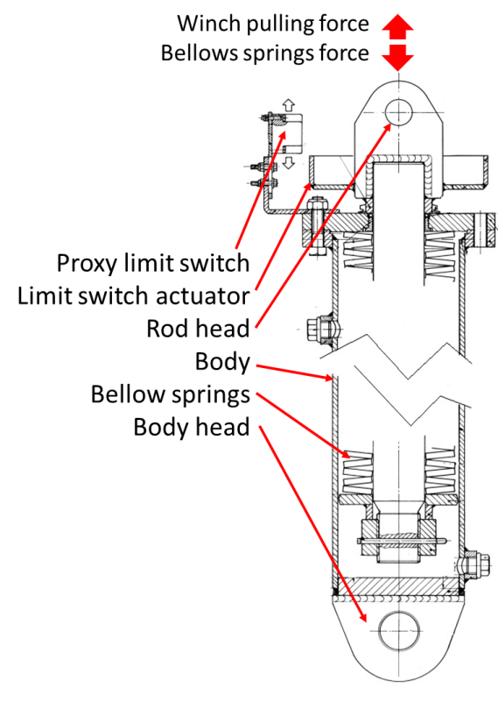  Mechanic shock absorber  sectional view
REFERENCE:
LSA stations with electric winch - shock absorbers – mechanic type – part replacement and inspection interval.
DISTRIBUTION:
All IACS members and all companies having Tecnimpianti LSA station with mechanic shock absorbers, all Navalimpianti Tecnimpianti Group Certified LSA Service Engineers.
EXTRA OPERATING SAFETY INSTRUCTIONS:
None, not applicable.

