DATE: | 10/12/2015 |  | MARINE SAFETY BULLETIN: | 08/15US
 |  |  | PRIORITY LEVEL: | HIGH
EQUIPMENT: SB-08-2015-Shock absorbers - Hydraulic type
Installed on Davit stations with winch operated by electric lifting motor only.
INSTRUCTIONS VALIDITY AND APPLICABILITY:
• Applicability: immediate. The instruction of this Marine Safety Bulletin supersedes any other previous instruction in: OMM, Service Instructions, Service Manuals, and any other instruction in written or verbal mode related to the interval of inspection of any and every hydraulic type shock absorber built by Tecnimpianti S.p.A.
• Starting date: Date of issue of the present bulletin (making reference for the hose and bladder accumulator to the date of commissioning / to the date of the last replacement whichever is the latest.
• End date: this instruction never expires.
• Vessel: all vessels with Tecnimpianti LSA stations with hydraulic type shock absorbers.
BULLETIN CONTENT AND CLARIFICATIONS:
The clarification and instruction of this Bulletin applies to all inspections on every Lifeboat / Tender / Rescue LSA Station built by Tecnimpianti S.p.A. that have hydraulic type shock absorbers.  The hydraulic type shock absorbers system has been designed to operate on application heavy duty, as on Tender boats, with maintenance on long time interval.  The above performances have been checked and no one unit has failed in over 15 years of operating life.  The function of the shock absorber is to prevent excessive pulling force on the wire rope and stresses to the davit structures and winch when the block and arms arrives to the mechanical stop in stowed position. At the end of the stroke, the wire rope (8) pulls out the rod of the shock absorber hydraulic cylinder (1); in the cylinder the oil is kept in pressure by the bladder accumulator (2) acting as a spring that limits the traction force; the other chamber of the cylinder is connected to the atmosphere via an air breathing filter (7). When the rod is pulled out the mechanical actuator abandons the limit switch (6) that stops the winch electric motor.  Depending on the boat weight the hydraulic shock absorber may have different size (cylinder internal bore and rod diameter) therefore different operating pressures; refer always to the Approved OMM for the operating pressure of the actual unit.  The present yearly interval of inspection foresees:  - Check of the leakages and oil/nitrogen pressures.  - General parts condition.  The hydraulic flexible hose has to be replaced every 5 years at latest.  The bladder accumulator to be inspected, bladder replaced, and body pressure tested, every 10 years at latest.  Other parts to be replaced according to the actual conservation state. |  | 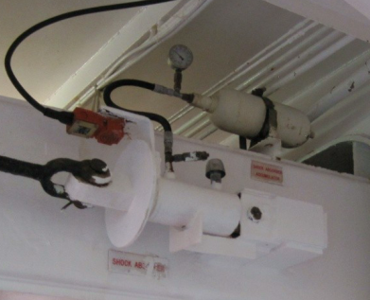  3  6  8  1  7  4  2  5  - Shock absorber - cylinder body  - Bladder accumulator  - Pressure gauge  - Quick connecting coupling  - Hydraulic flexible hose  - Limit switch (fail safe – stop the lifting motor)  - Air breathing filter / Plug (see note 1)  - Lifting wire rope dead end  Note 1) When the plug is installed the rear chamber is filled with nitrogen for corrosion protection purposes.  Do not open the plug.  ATTENTION! Never attempt to open hydraulic fittings if not after having slowly and fully released the oil pressure from the quick coupling
REFERENCE:
LSA stations with electric winch - shock absorbers - Hydraulic type – part replacement and inspection interval.
DISTRIBUTION:
All IACS members and all companies having Tecnimpianti LSA station with hydraulic shock absorbers, all Navalimpianti Tecnimpianti Group Certified LSA Service Engineers.
EXTRA OPERATING SAFETY INSTRUCTIONS:
None, not applicable.

