DATE: | 10/20/2015 | MARINE SAFETY BULLETIN: |  | 07/15US
 |  | PRIORITY LEVEL: |  | HIGH
EQUIPMENT: Hydraulic cylinders – all type
INSTRUCTIONS VALIDITY AND APPLICABILITY:
• Applicability: immediate. The instruction of this Marine Safety Bulletin supersedes any other previous instruction in: OMM, Service Instructions, Service Manuals, and any other instruction in written or verbal mode related to the interval of inspection of any and every hydraulic cylinder built by Tecnimpianti S.p.A.
• Starting date: applied since 1994 on Tecnimpianti LSA stations with Stored Power Systems (Telescopic type arm(s)) and from 2000 on semi-gravity type.
• End date: this instruction never expires.
• Vessel: all vessels with Tecnimpianti LSA station with telescopic arm(s) or semi-gravity type.
BULLETIN CONTENT AND CLARIFICATIONS:
The clarification and instruction of this Bulletin applies to all inspections on every Lifeboat / Tender / Rescue LSA Station built by Tecnimpianti S.p.A. that have telescopic arm(s) or semi-gravity type.  The hydraulic cylinder unit provides, for each LSA station, to the motion of the davits arm when hydraulic fluid pressure is applied; it is a pressure vessel.  The hydraulic cylinders used on LSA stations built by Tecnimpianti S.p.A. includes the following types and configurations:  - Single acting cylinders: the hydraulic fluid pressure is applied only to one chamber; the rod position is reset by external mechanical force.  - Double acting cylinders: the hydraulic fluid pressure can be applied alternatively to one or to the other chamber, or the chambers are blocked; the cylinder therefore can push out, or pull in, or keep the rod in a steady position.  - Standard type: the rod is single; the maximum rod displacement is less than the cylinder body length.  - Telescopic type the rod is built in concentric cylindrical sections sliding one inside the other; the configuration permit to have a rod displacement longer than the body.  NOTE: depending on LSA configuration characteristics 1 or 2 and 3 or 4 can be combined (i.e 1/3 and 2/4 are valid combination too).  The body and the rod are complete with mechanical connections to the davit’s structure and to the moving part according to the specific LSA design.  The hydraulic cylinder operates any time it is operated the LSA station.  The present yearly interval of inspection foresees:  - Check hydraulic fluid leakages (ports and rod seal).  - Check corrosion condition on body  - Check surface damages or corrosion on the fully extended rod.  At 10 (ten) years from the date of first installation, or from the last refurbishment, or in case it is detected hydraulic fluid leakage on the rod seal or on connection ports, the cylinder have to be:  - Disassembled from the LSA station and carried to specialized workshop.  - Disassembled and parts inspected.  - Exterior, checked to identify corrosion spots.  - Interior, checked for possible mechanical damage.  - Rod, checked for surface damages or corrosion (if damaged/corroded the rod have to be replaced).  - Mechanical connections, inspected for corrosion / welding damages.  - Ports for hydraulic fluid:  - Welded port: inspected for weld and body corrosion.  - Flanged port: inspect the surface for corrosion.  - Flush port: inspect the recessed surface for corrosion.  - If the cylinder is found in acceptable / recoverable conditions, needs the following overhaul:  - Repair of structural / mechanical problems, if any.  - Replacement of the rod if damaged.  - Replacement of all seals, guiding rings, O-rings ad gaskets.  - Replacement of spherical joints.  - Ports (if any found not acceptable):  - Welded port: replace and weld new ports for hydraulic fluid.  - Flanged port: mill and polish the surface.  - Flush port: mill and polish the surface.  - Body provided with new anti-corrosion protection cycle.  - After re-assembly has to be performed a pressure test at 1.5 times the LSA system design pressure (indicated on the LSA system HPP plate or in the OMM). |  |  | 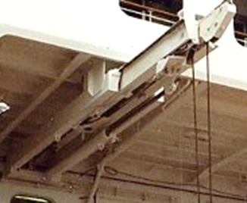  Telescopic davit  Standard double-acting hydraulic cylinder  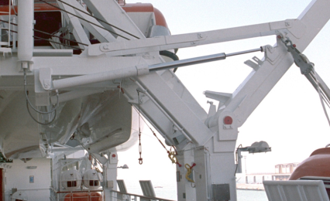  Semi-gravity davit  Telescopic type single-acting hydraulic cylinder  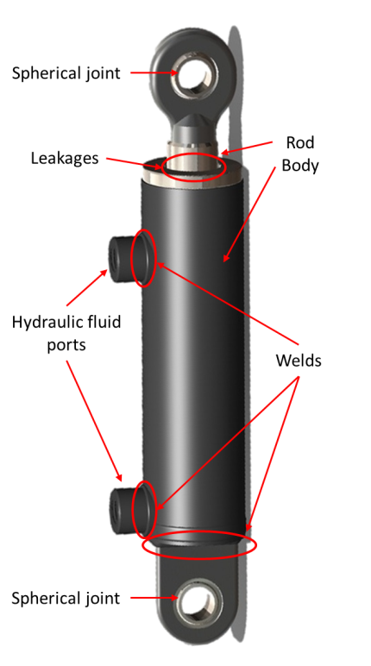  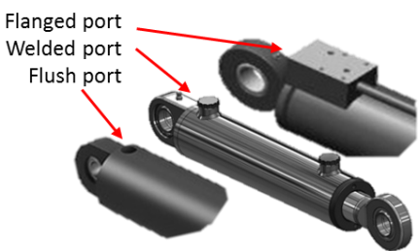
REFERENCE:
Hydraulic cylinders opening and internal inspection interval.
DISTRIBUTION:
All IACS members and all companies having Tecnimpianti LSA stations with telescopic arm(s) or semi-gravity type, all Navalimpianti Tecnimpianti Group Certified LSA Service Engineers.
EXTRA OPERATING SAFETY INSTRUCTIONS:
None, not applicable.

