DATE: | 10/20/2015 | MARINE SAFETY BULLETIN: |  | 05/15US
 |  | PRIORITY LEVEL: |  | HIGH
EQUIPMENT: Hydraulic accumulator - Piston type
INSTRUCTIONS VALIDITY AND APPLICABILITY:
• Applicability: immediate. The instruction of this Marine Safety Bulletin supersedes any other previous instruction in: OMM, Service Instructions, Service Manuals, and any other instruction in written or verbal mode related to the interval of inspection of any and every hydraulic accumulator, piston type built by Tecnimpianti S.p.A.
• Starting date: applied since 1994 on Tecnimpianti LSA stations with Stored Power Systems (Telescopic type arm(s)).
• End date: this instruction never expires.
• Vessel: all vessels with Tecnimpianti LSA station with telescopic arm(s)
BULLETIN CONTENT AND CLARIFICATIONS:
The clarification and instruction of this Bulletin applies to all inspections on every Lifeboat / Tender / Rescue LSA Station built by Tecnimpianti S.p.A. that have telescopic arm(s).  The hydraulic accumulator is a pressure vessel providing, for each LSA station, the volume of hydraulic fluid necessary to safely perform the launching procedure of the lifeboat also in case of blackout.  The accumulator includes a piston, normally kept in the top position by the hydraulic fluid pressure that is higher than nitrogen pressure, acting on the other surface. A set of nitrogen bottles of suitable total capacity is provided for each LSA station. In case of blackout, and in all other cases that may be necessary, the nitrogen pressure pushes the piston against the oil displacing the necessary volume of fluid to the hydraulic cylinders that drive the telescopic arms. The volume of fluid stored, and the capacity of the nitrogen bottles, is in excess to the volume needed for the full extension of the cylinder permitting also the adjustment of the boat position at embarkation deck as needed.  The above performances have been checked and the systems have performed their work well over the minimum limits of SOLAS rules also in real conditions of ship abandon (see Costa Concordia).  The hydraulic accumulator operates any time it is operated the LSA station.  The present yearly interval of inspection foresees:  - Check for nitrogen and hydraulic fluid leakage.  - Check of corrosion condition on body, covers and bolts  - Check of hydraulic fluid leakage on nitrogen side.  - Check of the correct indication of the level switch that detect the piston top position.  At 10 (ten) years from the date of first installation, or from the last refurbishment, or in case it is detected hydraulic fluid leakage on nitrogen side, the accumulator have to be:  - Disassembled in shop.  - Exterior, checked to identify possible corrosion spot  - Interior, checked for possible mechanical damage  - If found in acceptable / recoverable overall conditions, needs the following overhaul:  - Repair of body corrosion problems, if any.  - Replacement of all seals, O-rings ad gaskets.  - Replacement of all bolts (original Navalimpianti high tensile strength bolts with anticorrosion treatment must be used).  - After re-assembly the accumulator to be provided with new anti-corrosion protection cycle.  - Has to be performed a final pressure test, on nitrogen and on hydraulic fluid side, at 1.5 times the LSA system design pressure, indicated on the HPP plate. |  |  | 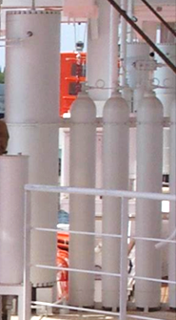  Accumulator and nitrogen bottles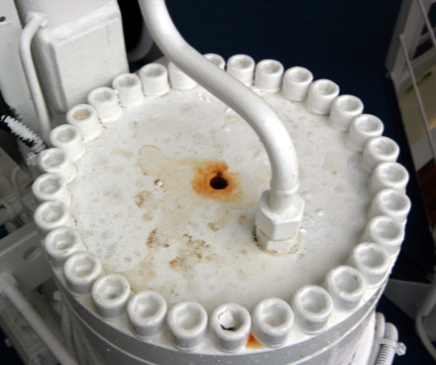  Accumulator bolts  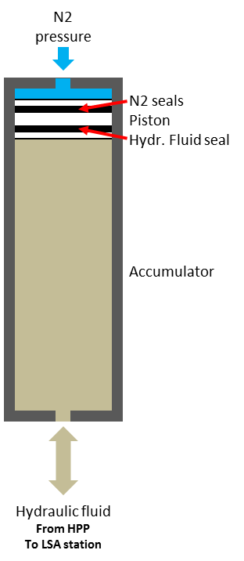
REFERENCE:
Hydraulic Accumulator opening and internal inspection interval.
DISTRIBUTION:
All IACS members and all companies having Tecnimpianti LSA stations with telescopic arm(s), all Navalimpianti Tecnimpianti Group Certified LSA Service Engineers.
EXTRA OPERATING SAFETY INSTRUCTIONS:
None, not applicable.

