DATE: | 10/20/2015 | MARINE SAFETY BULLETIN: |  | 06/15US
 |  | PRIORITY LEVEL: |  | HIGH
EQUIPMENT: Hydraulic accumulator - Bladder type
INSTRUCTIONS VALIDITY AND APPLICABILITY:
• Applicability: immediate. The instruction of this Marine Safety Bulletin supersedes any other previous instruction in: OMM, Service Instructions, Service Manuals, and any other instruction in written or verbal mode related to the interval of inspection of any and every hydraulic accumulator, piston type built by Tecnimpianti S.p.A.
• Starting date: applied since 2000 on Tecnimpianti LSA stations semi-gravity type.
• End date: this instruction never expires.
• Vessel: all vessels with Tecnimpianti LSA station with semi-gravity arm(s)
BULLETIN CONTENT AND CLARIFICATIONS:
The clarification and instruction of this Bulletin applies to all inspections on every Lifeboat / Tender LSA Station built by Tecnimpianti S.p.A. that have semi-gravity arms.  The hydraulic accumulator is a pressure vessel providing, for each LSA station, the volume of hydraulic fluid necessary to safely perform the launching procedure of the lifeboat in any condition. The accumulator is part of a closed circuit that includes the hydraulic cylinder that pushes out the davits arm; each arm has an independent circuit.  The accumulator body includes a bladder in elastomer, charged with a certain pressure of nitrogen, lower than the design pressure. The nitrogen charge pressure depends on system design; refer to the OMM for the pressure value of the actual system.  The hydraulic fluid enters the accumulator, shrinking the bladder volume, when the davits arm, moved by the winch, goes to the stowed position pushing the cylinder rod.  When the winch brake is released the nitrogen pressure pushes out the cylinder and davit arm to the maximum outrigged position.  The above performances have been checked and the systems operating without problems since first installation.  The hydraulic accumulators are operated any time it is operated the LSA station.  The present yearly interval of inspection foresees:  - Check of the nitrogen pressure charge.  - Check of the hose and fittings of the closed circuit.  - Check of the hydraulic cylinder conditions.  - Check for leakage of the closed circuit.  At 10 (ten) years from the date of first installation, or from the last refurbishment, or in case it is detected hydraulic fluid leakage on nitrogen side, the accumulator have to be:  1. Disassembled in shop.  2. Exterior checked to identify possible corrosion spot  3. Interior checked for possible mechanical damage  4. If found in acceptable conditions it needs the following overhaul:  - Replacement of all seals, O-rings ad gaskets.  - If found defective: replacement of nitrogen charging connection and / or anti-extrusion valve.  - Body pressure test performed at 1.5 times the original accumulator design pressure.  - Replacement of the bladder.  - Recharge of Nitrogen to the specific system / LSA station pressure. |  |  | 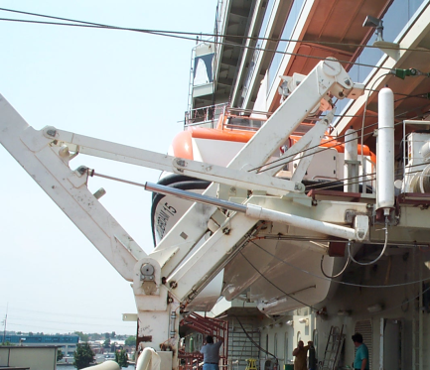  Semi-gravity davit  Bladder accumulator  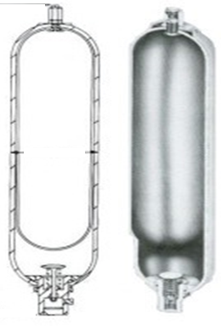  Bladder accumulator  Sectional view  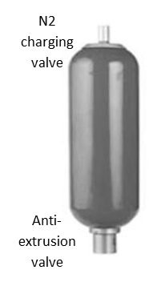
REFERENCE:
Hydraulic Accumulator opening and internal inspection interval.
DISTRIBUTION:
All IACS members and all companies having Tecnimpianti LSA stations semi-gravity type, all Navalimpianti Tecnimpianti Group Certified LSA Service Engineers.
EXTRA OPERATING SAFETY INSTRUCTIONS:
None, not applicable.

