DATE: | 10/12/2015 |  | MARINE SAFETY BULLETIN: | 04/15US
 |  |  | PRIORITY LEVEL: | HIGH
EQUIPMENT: TECNIMPIANTI Winches - see attached detailed list for types and ships
Items: “Main transmission chain”, “brake shaft sprocket gear” and “tank epicyclical gearbox ”
INSTRUCTIONS VALIDITY AND APPLICABILITY:
• Applicability: immediate.
The instruction of this Marine Safety Bulletin supersedes any other previous instruction in: OMM, Service Instructions, Service Manuals, and any other instruction in written or verbal version related to the interval of replacement of the “main transmission chain”, “brake shaft sprocket gear”, and “tank epicyclical gearbox” of any and every winch of the above type.
• Starting date: Date of issue of the present bulletin (The reference for the main transmission chain life to the date of commissioning / to the date of the last replacement whichever is the latest.
• End date: This bulletin will not expire unless specifically mentioned in an updated version.
• Vessel: All vessels with Tecnimpianti LSA’s Winches with any combination of “Main transmission chain”, “brake shaft sprocket gear” and “ tank epicyclical gearbox”
BULLETIN CONTENT AND CLARIFICATIONS:
The clarification and instruction of this Bulletin applies to all inspections on every Lifeboat / Tender / Rescue boats LSA’s Station built by Tecnimpianti S.p.A. where installed one winch of the type listed in annex.  The main gearbox unit has been designed to operate on heavy duty application, as on Tender boats, with maintenance on long time interval.  The main gearbox unit cinematic chain can have one of the following configurations:  - an epicyclical gearbox used in “Y” configuration that includes #3 mechanical connections:  - In shaft, from the electric motor  - Out shaft to the drum gearbox  - Casing sprocket gear that connects the brake shaft via the main transmission chain.  - an epicyclical gearbox used in “Y” configuration that includes #3 mechanical connections:  - In shaft, from the electric motor  - Out shaft to the drum gearbox  - Casing gear that connects the brake shaft via set of gears.  - an epicyclical gearbox used in “Y” configuration that includes #3 mechanical connections:  - In shaft, from the electric motor  - Out shaft to the brake mechanism  - Casing gear that connects to the drum gearbox shaft via set of gears.  No one unit has failed prior than 11 years of operating life.  The present yearly interval of inspection tests the integrity of the whole main transmission chain because foresees:  - The yearly opening and inspection of the main gearbox to observe the status of the components of the cinematic chain.  - The winch performance test (braking capacity); at each yearly inspection.  - The winch performance test (dynamic overload braking capacity); at each 5 year inspection.  It is mandatory to replace every 10 years according to the winch configuration the following parts:  - Configuration 1:  - Tank epicyclical gearbox.  - Main transmission chain.  - Brake shaft sprocket gear.  - Configurations 2 and 3  - Tank epicyclical gearbox. |  | CONFIGURATION 1  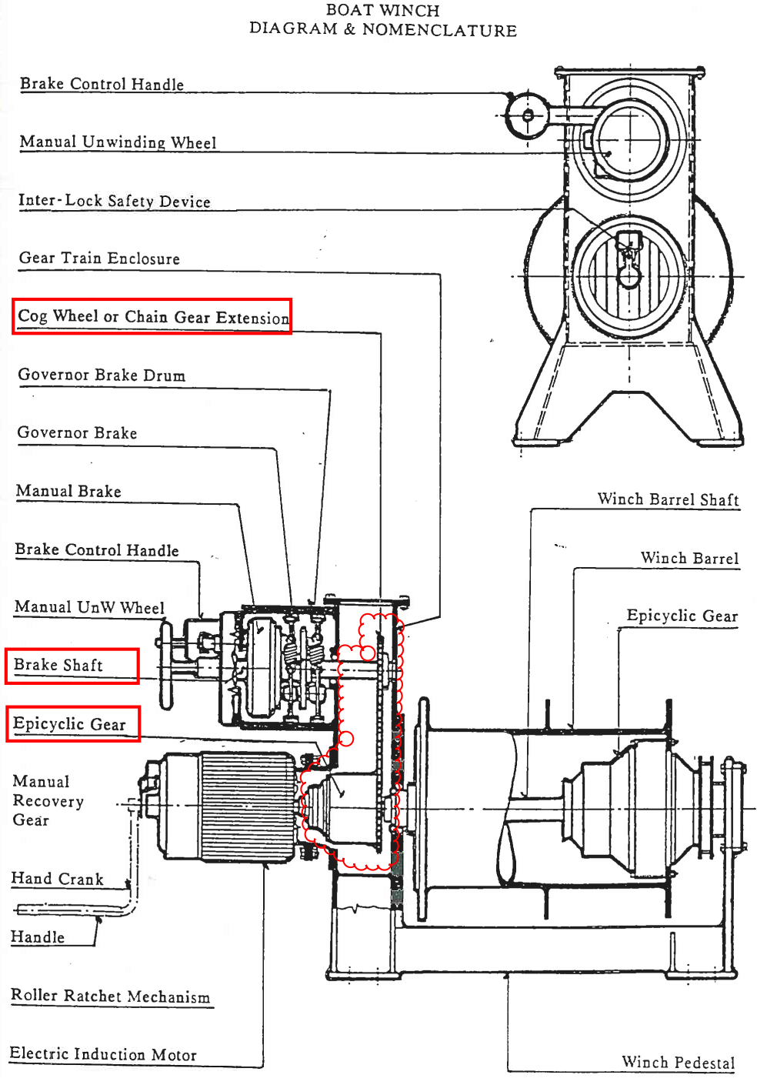  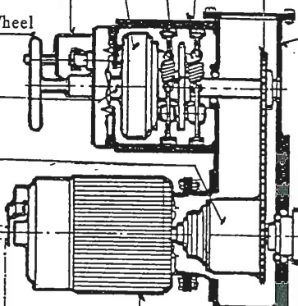 Detail  - Brake shaft sprocket gear  - Chain  - Epicyclical  Gearbox  CONFIGURATION 2  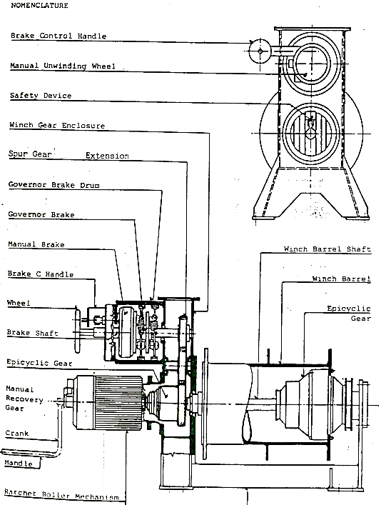  CONFIGURATION 3  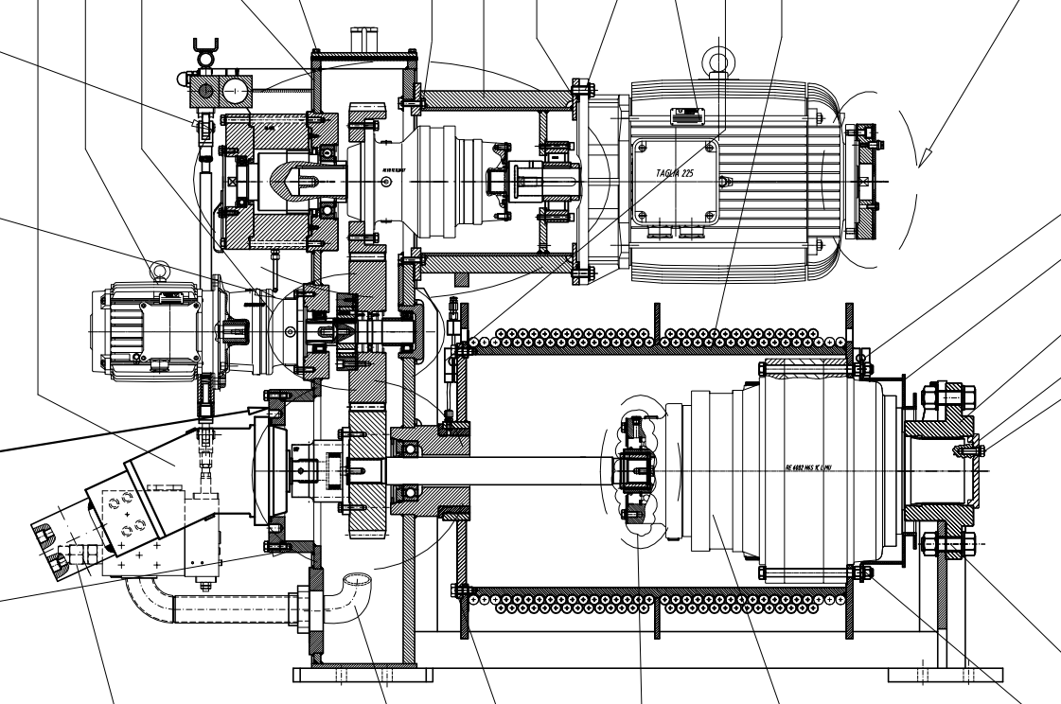
REFERENCE:
Winch: main transmission chain, brake shaft sprocket gear and tank epicyclical gearbox replacement interval.
DISTRIBUTION:
All IACS members and all companies having Tecnimpianti LSA Winches listed in annex and all Navalimpianti Tecnimpianti Group Certified LSA Service Engineers.
EXTRA OPERATING SAFETY INSTRUCTIONS:
None, not applicable.

Annex - List of winch types and ships
Known Owner | IMO No | Ship name | Q.ty installed | Year of delivery | Winch type
P&O | 8521220 | Pacific Jewel | 8 | 1990 | 3-38-18
P&O | 8521220 | Pacific Jewel | 4 | 1990 | 3-58-09
P&O | 8521220 | Pacific Jewel | 2 | 1990 | 3-22-14
P&O | 8521232 | Pacific Dawn | 8 | 1991 | 3-38-18
P&O | 8521232 | Pacific Dawn | 4 | 1991 | 3-58-09
P&O | 8521232 | Pacific Dawn | 2 | 2007 | EW10
Costa Cruise Line | 8716502 | Costa Classica | 8 | 1991 | 2-38-10
Costa Cruise Line | 8716502 | Costa Classica | 4 | 1991 | 2-58-11
Costa Cruise Line | 8716502 | Costa Classica | 2 | 1991 | 2-22-13
Holland American Line | 8919245 | Statendam | 6 | 1993 | 2-38-10
Holland American Line | 8919245 | Statendam | 4 | 1993 | 2-38-11
Holland American Line | 8919245 | Statendam | 2 | 1993 | 2-22-13
Holland American Line | 8919257 | Maasdam | 6 | 1993 | 2-38-11
Holland American Line | 8919257 | Maasdam | 4 | 1993 | 2-38-10
Holland American Line | 8919257 | Maasdam | 2 | 1993 | 2-22-13
Costa Cruise Line | 8821046 | Costa NeoRomantica | 8 | 1993 | 2-38-10
Costa Cruise Line | 8821046 | Costa NeoRomantica | 4 | 1993 | 2-58-11
Costa Cruise Line | 8821046 | Costa NeoRomantica | 2 | 1993 | 2-22-13
Holland American Line | 8919269 | Ryndam | 6 | 1994 | 2-38-11
Holland American Line | 8919269 | Ryndam | 4 | 1994 | 2-38-10
Holland American Line | 8919269 | Ryndam | 2 | 1994 | 2-22-13
Princess Cruises | 9000259 | Sun Princess | 10 | 1995 | 3-38-18
Princess Cruises | 9000259 | Sun Princess | 2 | 1995 | 3-38-18
Princess Cruises | 9000259 | Sun Princess | 4 | 1995 | 3-58-15
Holland American Line | 9102992 | Veendam | 6 | 1996 | 2-38-10
Holland American Line | 9102992 | Veendam | 4 | 1996 | 2-38-11
Holland American Line | 9102992 | Veendam | 2 | 1996 | 2-22-13
Carnival Cruise Lines | 9070058 | Carnival Sunshine | 18 | 1996 | 2-38-11
Carnival Cruise Lines | 9070058 | Carnival Sunshine | 2 | 1996 | 2-22-13
Carnival Cruise Lines | 9070058 | Carnival Sunshine | 4 | 2013 | SDHW 200
Princess Cruises | 9103996 | Dawn Princess | 10 | 1997 | 3-38-18
Princess Cruises | 9103996 | Dawn Princess | 2 | 1997 | 3-38-18
Princess Cruises | 9103996 | Dawn Princess | 4 | 1997 | 3-58-15
Holland American Line | 9122552 | Rotterdam VI | 6 | 1997 | 2-38-10
Holland American Line | 9122552 | Rotterdam VI | 4 | 1997 | 3-58-15
Holland American Line | 9122552 | Rotterdam VI | 4 | 1997 | 2-22-13
Holland American Line | 9221279 | Zuiderdam | 10 | 2002 | EW10
Holland American Line | 9221281 | Oosterdam | 10 | 2003 | EW10
Holland American Line | 9226891 | Westerdam | 10 | 2004 | EW10
P&O- Cunard | 9226906 | Arcadia | 12 | 2005 | EW10
Holland American Line | 9230115 | Noordam | 10 | 2006 | EW10

Known Owner | IMO No | Ship name | Q.ty installed | Year of delivery | Winch type
Holland American Line | 9378448 | Eurodam | 12 | 2008 | EW10
Costa Cruise Line | 9398905 | Costa Luminosa | 2 | 2009 | SDHW50
Costa Cruise Line | 9398917 | Costa Deliziosa | 2 | 2010 | SDHW50
Holland American Line | 9378450 | Niew Amsterdam | 12 | 2010 | EW10
Oceania | 9438066 | Oceania Marina | 6 | 2008 | SDHW-93
Oceania | 9438066 | Oceania Marina | 4 | 2008 | SDHW-140
Oceania | 9438066 | Oceania Marina | 2 | 2008 | EWR6
Oceania | 9438078 | Oceania Riviera | 6 | 2008 | SDHW-93
Oceania | 9438078 | Oceania Riviera | 4 | 2008 | SDHW-140
Oceania | 9438078 | Oceania Riviera | 2 | 2008 | EWR6

